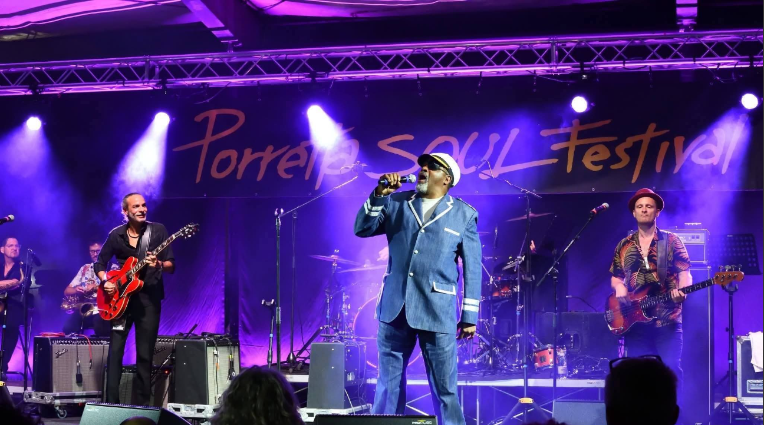
He and his twin brother were adopted by his uncle and aunt, George and Wessie Mae Watson at the age of 18 months old and moved to Dallas, Texas in 1968. Captain Jack often played in church and joined the school band at Wilmer Hutchins High School. Captain Jack sung in the youth’s choir and played drums at 10 years old and was introduced to the blues world by his Uncle Morris White who formally was Bobby Patterson first manager. His uncle was known in Dallas as a great guitar player. Morris taught him and his twin how to sing and play the blues. At age 14, Captain Jack formed his first blues band which was managed by his older brother Roy Cassell and his uncle Larry White. Captain Jack played the drums in the marching band under the leadership of Bobby Simpson, who also played with Bobby Patterson and The Mustangs. On Thursday nights, Captain Jack was asked to sing on stage at the Coaches Corner giving him his first big break. Captain Jack was introduced to another world of the blues when Big Charles Young would call him on stage at RL Blues Palace and past him the microphone and let him get down.
Captain Jack has opened for artists such as Little Milton, TJ Hooker, Floyd Taylor, Jeff Floyd, TK Soul, Carl Marshall, Rue Davis, Joe Tex, Jr., Donnie Ray Aldridge, Vernon Garrett, L.J. Echols, The Rose Brothers, Bobby Patterson, Ernie Johnson, Greg Smith, Silver Tones, Miss Levell White, Lil Dave Thomas, Blue Lisa & The Big D Play Boys, Cheryl Arena, Joe Jonas, Tu. Tu Jones, Jonnie T. Harris, Christian Dozzler, Willie Clayton, Wilson Meadows, Sir Charles Jones, Texas Slim and many more. Captain Jack's squalling has been compared to the late Z.Z. Hill, Bobby Blue Bland, and the late Little Milton. Many blues lovers will be blessed by his voice and energetic stage performance.
Captain Jack Watson was signed with CDS Records Entertainment, LLC in 2009 for one year. His CD is titled “Brand New Man” it was released March 2, 2010.
Captain Jack dropped his first single as an Independent Artist…”That Right Kind Of Loving”. And, with the help of DJ Jazzi Pete from Australia, his second single “Real Deal was released in 2015. At this time Captain Jack is not signed to a record label.
Captain Jack would like to thank God for allowing him to step out on faith to reach beyond limitations to enjoy the gift of singing that is bestowed upon him.
Thank you.
captainjackbluessinger@yahoo.com
www.facebook/Burnett Captain Jack Watson
www.facebook/fan Captain Jack Watson “Da Captain”

